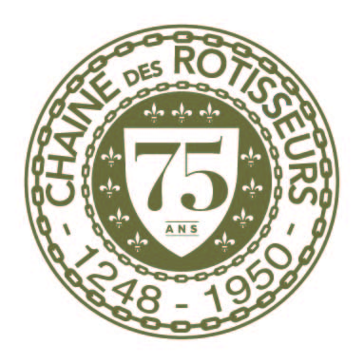

BAILLIAGE OF NEW ZEALAND

**Grand Chapitre**

**Friday 11 – Sunday 13 April 2025**

**Welcome from our Bailli Delegue**

Mes Chers Amis

A very warm welcome from Auckland and New Zealand. I would like to invite you to attend our Grand Chapitre on Friday 11th to Sunday 13th April 2025.

Olivier Lacoua our Auckland Bailli and Rowan Moss our Chancelier have put together a wonderful programme featuring some of Auckland’s most celebrated restaurants. We have also allowed time in the programme for you to enjoy the sites and attractions of our largest city.

We look forward to meeting you for a memorable weekend.

Vive La Chaine

**David Shackleton, Bailli Delegue**

Kia Ora – Bonjour!

Greetings from the members of the Auckland Bailliage to our worldwide Chaine Confreres. We are delighted to welcome you to Auckland, known in New Zealand as ‘The City of Sails’. Auckland has so much to offer, including some of the finest restaurants, chefs and wineries in the country, a couple of which you will sample over the next three days.

Nau mai haere mai,

Welcome and Vive La Chaine

**Olivier Lacoua, Auckland Bailli & Rowan Moss, Chancelier**

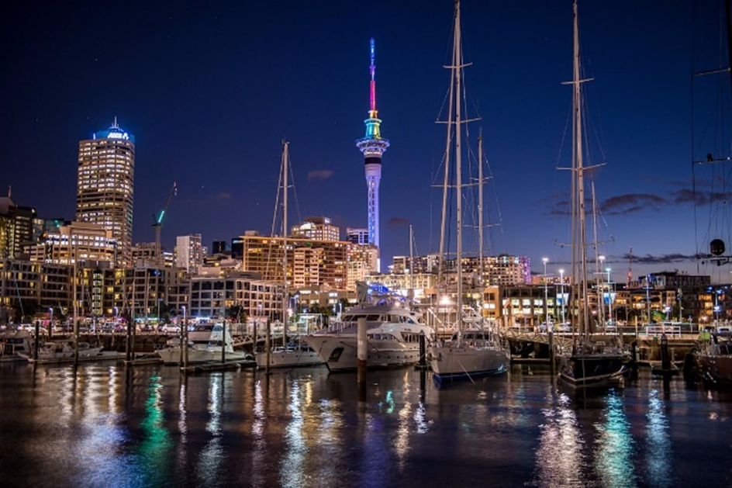

**PROGRAMME – Thursday 10 April 2025**

**GILT Brasserie – Unofficial Function**

2 Chancery St. Auckland CBD. Auckland 1010

18:00 Dinner

Dress: Smart Casual

**About the Location**

GILT Brasserie is an all-day, inner-city brasserie serving contemporary European fare with local charm from the Heart of Auckland’s Historic Chancery Chambers Building. Just 5 Minutes’ Walk from the Pullman Auckland.

**PROGRAMME – Friday 11 April 2025**

**PULLMAN Auckland – Official Welcome Cocktail Function**

Corner Waterloo Quadrant & Princes Street, Auckland CBD 1010

18:00 Ground floor meeting in the entry foyer

18.05 **Cocktail** - Viewing Platform

Dress: Smart Casual with Regalia

**ONSLOW by Josh Emett**

9 Princes Street, Auckland CBD 1010

*Note: the restaurant is located opposite the road from Pullman Hotel*

18.35 Welcome Bubbles

19.00 **Dinner**

Dress: Smart Casual with Regalia

**About the Location/Restaurant**

Onslow is the culmination of Josh Emett’s culinary journey from London to New York and back to Aotearoa. A landmark Auckland address steeped in history; Onslow references the Old World but is decidedly modern; a sophisticated yet relaxed restaurant that celebrates New Zealand’s exceptional provenance.

**PROGRAMME – Saturday 12 April 2025**

**ORIGINE by Ben Bayly**

Commercial Bay. Level 2 / 172 Quay Street, Auckland CBD 1010

*Note: no transport provided, it is walking distance from the Pullman hotel (1km)*

12:00 **Lunch**

Dress: Smart Casual - *with Regalia*

**About the Location/Restaurant**

Origine is a Kiwi-styled bistro and sister restaurant to Ahi, offering a range of New Zealand classics crafted by Chef Ben Bayly. Located in the heart of downtown at Auckland’s newest shopping and dining precinct, Commercial Bay, Origine boasts breathtaking views of the Waitemata, Harbour Bridge, and the heritage-listed Auckland Ferry Building.

14:00 Afternoon Activities

About the Location/Activities – book at your leisure directly from the following link

<https://www.getyourguide.com/auckland-l822/>

Hop-On Hop-Off Auckland Explorer Bus (0900-1700) NZ$65 per adult

Scenic Harbour Sightseeing Cruise – Starting time 1330 (1.30hour) NZ$39 per adult

Flavours of the City Walking Food Tour – Starting time 1430 (3 hours) NZ$175 per adult

All Blacks Experience - 'A New Zealand Experience' (45mins) NZ$65 per adult

Afternoon Harbour 1.5-Hour Sailing Cruise – Starting time 1515 NZ$99 per adult

**THE HELIER – Grand Chapitre Dinner Auckland 2025**

28 Waimarie Street, St Heliers, Auckland 1071

*Note: transport from/to the Pullman Hotel is included in your evening function*

16:30 Coach departure from Pullman Hotel to The Helier

17:00 Main Lounge meeting

17.30 **Induction Ceremony**

18.30 **Cocktails**

19.00 **Dinner** “Taste of the world”

Dress: Formal Black Tie/Ladies – Evening Attire - *with Regalia*

21:30 Coach departure from The Helier to Pullman Hotel

**About the Evening**

Join us for a special dinner celebrating the induction of new members and honouring our long-serving members. Together, we’ll enjoy a five-course "Taste of the World" dinner to mark the 10th anniversary of World Chaine Day. A memorable evening of camaraderie and celebration awaits! The Helier, by Oceania, is a leading provider of premium retirement services in New Zealand. Oceania prides itself on creating bespoke services inspired by the community surroundings. With The Helier, Oceania has drawn inspiration from the magnificent views of the bay area, designing retirement residences for locals who love the St Heliers lifestyle. The Helier enables you to continue the lifestyle you love, but with bespoke care that's unmatched by a typical retirement village. Oceania is consistently recognised for their leadership and innovation in aged care. It's their belief in better that makes them different.

**PROGRAMME – Sunday 13 April 2025**

**TANTALUS ESTATE**

70/72 Onetangi Road, Onetangi, Waiheke Island 1971

10:00 Ferry Building

*Note: Ferry Building is a walking distance from the Pullman Hotel (1km)*

10:30 Ferry Fullers360 from Auckland to Waiheke (Approx. 40 mins)

11:15 Coach transfer from Ferry to restaurant

11.45 Welcome drinks

12.15 **Lunch**

Dress: Casual - *with Regalia*

16:00 Coach transfer from restaurant to Ferry

17:00 Ferry Fullers360 from Waiheke to Auckland (Approx. 40 mins)

*Note: The Pullman Hotel is a walking distance from Ferry Building (1km)*

**About the lunch**

Tantalus Estate is a family owned, premium vineyard destination located in the heart of Onetangi Valley, Waiheke Island. Established in 2016, our award-winning Estate is an iconic location for world-class cuisine, wine tasting, craft beer, weddings, events and special occasions. Our passion is to provide a tantalising and personal experience across everything we do.

**How to RSVP**

Please outline which functions you will be attending, the number in your party, and the name of your guest to:

Olivier Lacoua, email [Olivier.lacoua@oceaniahealthcare.co.nz](mailto:Olivier.lacoua@oceaniahealthcare.co.nz)

Please reply no later than **Monday 10th March 2025**

**Functions**

**Thursday 10 April 2025**

|  |  |
| --- | --- |
| * **Gilt Brasserie Dinner** (unofficial) | $PYO |

|  |  |
| --- | --- |
| * Number of people |  |

|  |  |
| --- | --- |
| * Guest Names |  |
|  |  |
|  |  |

**Friday 11 April 2025**

|  |  |
| --- | --- |
| * Pullman Cocktail, **$52** p. person* |  |

*\*non-member, $55*

|  |  |
| --- | --- |
| * Onslow Dinner, **$265** p. person* |  |

*\*non-member, $275*

|  |  |
| --- | --- |
| * Number of people |  |

|  |  |
| --- | --- |
| * Guest Names |  |
|  |  |
|  |  |

**Saturday 12 April 2025**

|  |  |
| --- | --- |
| * Origine Bistro Lunch, **$170** p. person* |  |

*\*non-member, $180*

|  |  |
| --- | --- |
| * Number of people |  |

|  |  |
| --- | --- |
| * Guest Names |  |
|  |  |
|  |  |

|  |  |
| --- | --- |
| * The Helier Dinner, **$255** p. person* |  |

*\*non-member, $265*

|  |  |
| --- | --- |
| * Number of people |  |

|  |  |
| --- | --- |
| * Guest Names |  |
|  |  |
|  |  |

**Sunday 13 April 2025**

|  |  |
| --- | --- |
| * Tantalus Lunch**, $235** p. person* |  |

*\*non-member, $245*

|  |  |
| --- | --- |
| * Transport, **$89** p. person | Ferry & Coach Waiheke round trip |

|  |  |
| --- | --- |
| * Number of people |  |

|  |  |
| --- | --- |
| * Guest Names |  |
|  |  |
|  |  |

Payment method is direct credit to **Chaine Des Rotisseurs Auckland Chapter**

Account Number **06-0222-092889100 (Swift: ANZBNZ22)**

Please include your name, and the name of the function/s you will be attending.

**Accommodation**

For those of you coming from out of town, we have arranged special rates at the Pullman

PULLMAN Auckland Hotel & Apartments  
Cnr Princes St & Waterloo Quadrant – Auckland City – 1143 – New Zealand   
[www.pullmanauckland.co.nz](http://www.pullmanauckland.co.nz)

Rate: 15% off flexible rates (room only)

**Please make your reservations directly on this link:**

<https://shorturl.at/77unB>

*\*Rate applies 12th -15th April 2025 only. If you wish to stay outside these dates, kindly contact the reservation team at* [*reservations@pullmanauckland.co.nz*](mailto:reservations@pullmanauckland.co.nz) *to extend your stay. Ph +64 (9) 358 8023*



**REGISTRATION TO INDUCTION OR PROMOTION**

Please complete the form and return by email to [Olivier.lacoua@oceaniahealthcare.co.nz](mailto:Olivier.lacoua@oceaniahealthcare.co.nz)

If you would like to be inducted or promoted, please fill in this form:

If you would like to be inducted or promoted in another Bailliage or Country,

please fill in this form and also register yourself with the inducting Bailliage.

|  |  |
| --- | --- |
| INDUCTING COUNTRY | New Zealand |
| INDUCTING BAILLIAGE |  |
| DATE OF INDUCTION | Saturday 12 April 2025 |
| NAMES |  |
| MEMBERSHIP NUMBER |  |
| NEW ZEALAND BAILLIAGE |  |
| NEW GRADE |  |
| EMAIL ADDRESS |  |
| PHONE NUMBER |  |
| ***Office Only*** |  |
| ***Date Received/Approved*** |  |
| ***Signed Bailli Delegue*** |  |

Please ensure you send your Admission/Promotion form to your Bailli Delegue and get it approved and signed first.